|  |
| --- |
| 24/01/1999| in Qashqadaryo|  998906770959  [abbosakromovich777@gmail.com](mailto:abbosakromovich777@gmail.com) |

|  |  |
| --- | --- |
|  | fronted developer |

I want to work as a Front-End Developer, as part of one big team

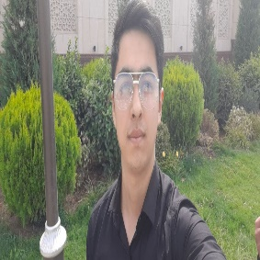

|  |  |
| --- | --- |
|  | education |

## TUIT, PDP

|  |  |
| --- | --- |
|  | SKILLS |

|  |  |
| --- | --- |
| * HTML * CSS * Bootstrap 4, Bootstrap 5 * Sass * Java Script * React * Redux * Github, netlify.com * Nextjs * GraphQl |  |

|  |  |
| --- | --- |
|  | ADDITIONAL INFORMATION |

I am creative in solving problems, I can easily establish contacts, I can be stress-resistant in any emergency, I like working in a team. I am a strong, creative and fair person. I prefer to listen before I say anything. Besides, I am a reliable person who is very good at managing my time.